LAB:

NAME: Reddy Dorniya

Reg: 192372061

**Pull in Git:**

1.Create a new file in the same github repository named dummy for example and click commit change.

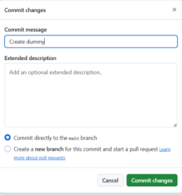

2.Now we can see the new file created in the repository.

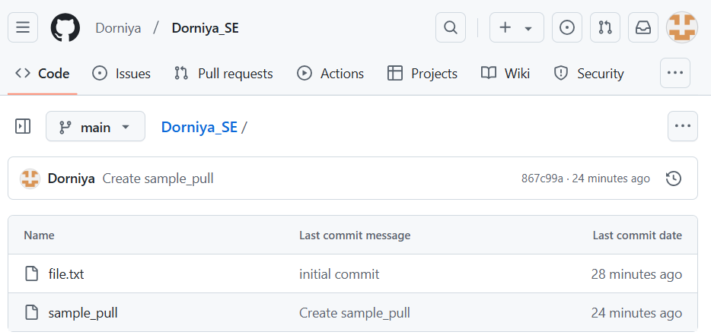

3.Now check the status by using git status command. It shows nothing to commit which means it does not show the commited change.

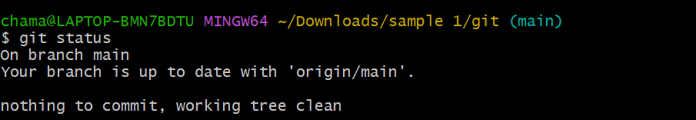

4.Now use git pull command to pull or display the changes maded in the repository

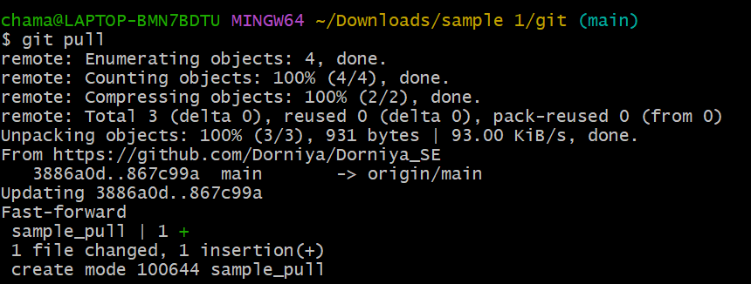

5.Thus, git pull displays the commited changes in the local storage of the same file.

